|  |  |
| --- | --- |
| **Project Name** | Automation of the Manual CPP Process |
| **Date** | 07 July 2022 |
| **Business Unit** | Commercial Lines Rating |
| **Purpose** | Optimize and automate the manual process of filling the dec pages from the PCS system using the QPP Proposals based on policy number and Insured Name. |

# Roles, Responsibilities, Acceptance Management

|  |  |
| --- | --- |
| **Document Information** | |
| **Project Name** | Manual CPP (Commercial Package Policy) Dec Prefill |
| **Authored By** | Vaishnavi Sharma |
| **Project Sponsor** | Michael Morrison |

| **Date** | **Name** | **Role** | **Email** |
| --- | --- | --- | --- |
| 07 July 2022 | Vaishnavi Sharma | Automation Analyst | vasharma@hanover.com |
| 07 July 2022 | Sarita Kosti | Automation Developer | [skoshti@hanover.com](mailto:skoshti@hanover.com) |
| 07 July 2022 | Vivek Kumar | Technology Architect | vkumar@hanover.com |
| 07 July 2022 | Cindy Hinton | Process Owner / Product Owner | [chinton@hanover.com](mailto:chinton@hanover.com) |
| 07 July 2022 |  | BU COE Lead/Manager |  |
| 07 July 2022 | Prashant Hinge | EAP Lead | [phinge@hanover.com](mailto:phinge@hanover.com) |

Contents

Roles, Responsibilities, Acceptance Management 1

Executive Summary 3

Current State Process Flow (As-is) 3

Current Process Description (As-is) 3

Project Overview 4

Project Scope 4

Objectives 5

Detailed To-Be flow: 5

Bot Steps: 6

Step 1: Receive email from rater to start the Manual CPP bot process. 7

Step 2: Download the QPP attached with the mail. 7

Step 3: Extract data according to the mapping from the QPP and store in an excel. 8

Step 4: Launch the PCS application 9

Step 5: Search for the policy number received in the email in PCS. 9

Step 6: If the policy number is found download the dec pages for the policy, according to the form numbers present in the email. 9

Step 7: If the policy number is not found, add the policy number, and then download the dec pages for the policy. 10

Step 8: Fill the dec pages with the data from the excel according to the mapping provided. 11

Step 9: Upon completion bot will send email to rater with the dec pages. 11

Target Systems 13

Impacted Business Area 13

Pre-requisites 13

Requirement Details 13

Exceptions Handling 14

Business Exceptions Handling 14

Application Error and Exceptions Handling 15

Assumptions, Risks, Dependencies, and Constraints 15

Assumptions 15

Risks 15

Dependencies 15

Constraints 16

Additional Information 16

Acronyms and Glossary 16

Change History 16

# Executive Summary

Currently, for non-automated policies, the declaration pages are completed manually by the rater. This requires the rater to copy or retype information into the declaration pages in the PCS system. The process is repetitive, time consuming and has a negative impact on rater morale. Depending on the size of the policy, it can take 8 hours or more to complete just the declaration page portion of the policy.

## Current State Process Flow (As-is)

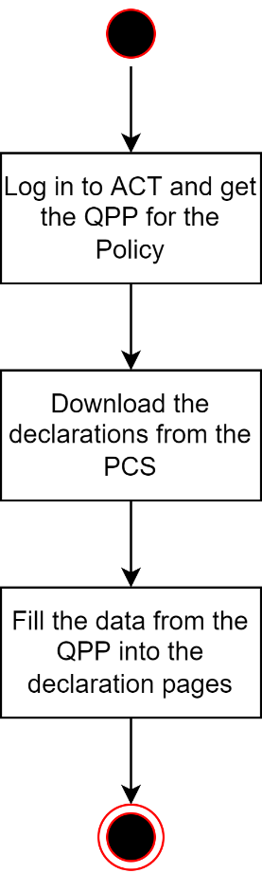

*Figure 1: Current State Process Flow*

## Current Process Description (As-is)

The rater must copy or retype information from multiple sources (ACT, PMS (Policy Management System)) into the declaration pages in PCS. This is a recurring and time-consuming process that requires a lot of manual effort. The business requires a process where the bot can read and map the data from QPP to the declaration forms from the PCS for each policy and fill the declaration forms and provide user with end-report of success or failure.

# Project Overview

The team of raters require an automation system, that can extract the required data from the QPP that will be shared with the bot over email with policy details and QPP. Bot extracts the data and stores it in an excel. The bot will then log into the PCS system and search for the policy, if the policy is found the bot will add Main Declaration, Crime declaration, Inland Marine declaration, General Liability declaration and Property declaration forms based on the form numbers present in the mail and download the forms for filling. If the policy is not found in PCS then the bot will first add the policy and then add the required forms. The bot will then fill the forms and save them to PCS. Once the process is completed for all the forms the bot will send an email to the rater along with the completed dec pages.

## Project Scope

**In Scope**

* Bot to read the policy details shared via mail.
* Bot to download the QPP attached with the mail
* Extracting the data from QPP to update the declaration pages
* Search the policy in PCS and download the declaration pages
* Fill the dec pages
* Send an email to the user after process completion
* Policies that are New Businesses(includes Large/Multiple Quote Polices, but the bot will only receive 1 QPP hence does not affect the scope.) and Renewals will only be part of the process.
* New Business Forms:

1. Main Dec Pages
2. Crime Dec Pages
3. Inland Marine Dec Pages
4. General Liability Dec Pages
5. Property Dec Pages
6. Cyber Dec Pages
7. Flood and Earthquake Dec Pages

* Renewal Forms:

1. Main Dec Pages
2. Crime Dec Pages
3. Inland Marine Dec Pages
4. General Liability Dec Pages
5. Property Dec Pages
6. Cyber Dec Pages
7. Flood and Earthquake Dec Pages

**Expected Incoming Volume**

* Approximately 200 policies per month
* Minimum 1 QPP file for each Policy

**Out of Scope**

* Fully Manual policies – OCP, RRP, HI, Discontinue Product Policies
* Large/Multiple Quote Policies (TBD – would like to include once NB is complete)
* COP (TBD – will evaluate if this is a viable option for the bot )
* Manual CPP Subsequent Transactions

## Objectives

The business objectives and benefits expected by the Business Process Owner after automation of the selected business process are:

* Extracting the data from QPP to update the declaration pages
* Search the policy in PCS and download the declaration pages
* Fill the dec pages
* Send an email to the user after process completion
* Eliminate repetitive and time-consuming tasks involved in the process.
* Optimize the process to improve overall efficiency and accuracy; thus, increasing rater satisfaction.
* **Operational Efficiencies-** Eliminate human errors.
* **Cost Savings -** TBA (do not have calculations on this presently)

## Detailed To-Be flow:

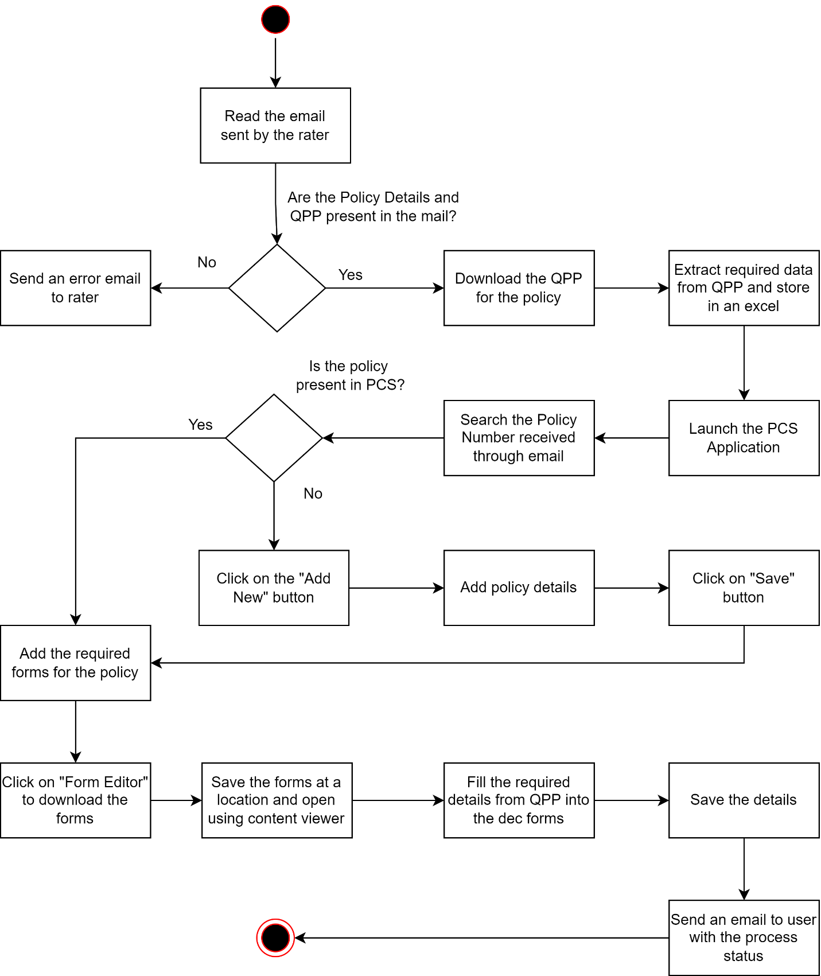

## Bot Steps:

**Step 1:** Receive email from rater to start the Manual CPP bot process.

**Step 2:** Download the QPP attached with the mail.

**Step 3:** Extract data according to the mapping from the QPP and store in an excel.

**Step 4:** Launch the PCS application

**Step 5:** Search for the policy number received in the email in PCS.

**Step 6:** If the policy number is found download the dec pages for the policy, according to the form numbers present in the email.

**Step 7**: If the policy number is not found, add the policy number, and then download the dec pages for the policy.

**Step 8:** Fill the dec pages with the data from the excel according to the mapping provided.

**Step 9:** Upon completion bot will send email to rater with the dec pages.

### Step 1: Receive email from rater to start the Manual CPP bot process.

### Step 2: Download the QPP attached with the mail.

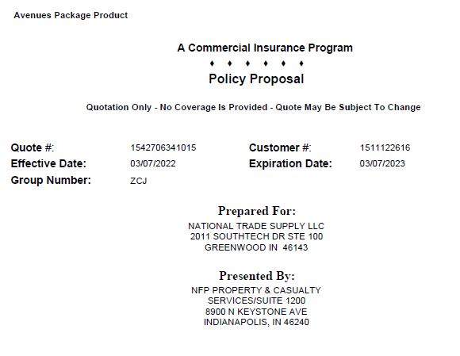

### Step 3: Extract data according to the mapping from the QPP and store in an excel.

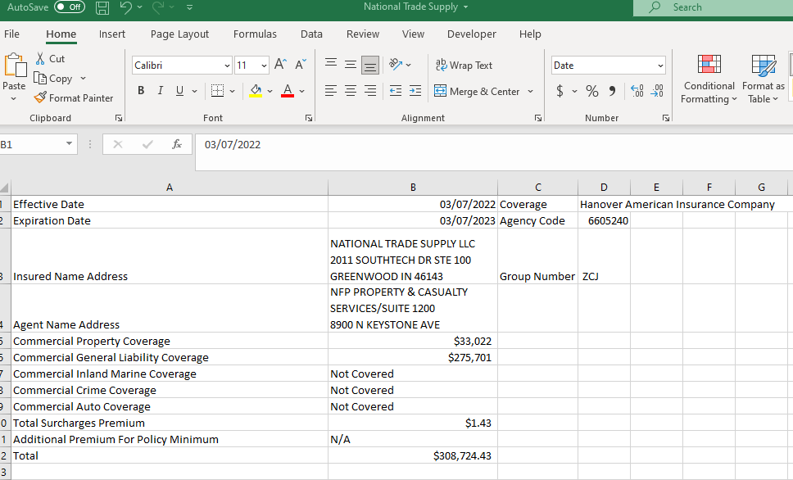

|  |  |  |
| --- | --- | --- |
| **Logical Entity** | **Business Name** | **Logical Data type** |
| Proposal | Core Rating | Numeric, String, Date |
| Effective Date | Main Dec Page: 401-0151 | Date |
| Expiration Date | Main Dec Page: 401-0151 | Date |
| Group Number | Main Dec Page: 401-0151 | Text |
| Coverage | Main Dec Page: 401-0151 | Number |
| Agency code | Main Dec Page: 401-0151 | Number |
| Agency name | Main Dec Page: 401-0151 | Text |
| Agency Address | Main Dec Page: 401-0151 | Text |
| Insured Name | Main Dec Page: 401-0151 | Text |
| Insured Address | Main Dec Page: 401-0151 | Text |
| Locations Number | Main Dec Page: 401-0151 | Text |
| Location Address | Main Dec Page: 401-0151 | Text |
| Commercial Property Coverage | Main Dec Page: 401-0151 | Number |
| Commercial Main Dec Page General Liability Coverage | Main Dec Page: 401-0151 | Number |
| Commercial Inland Marine Coverage | Main Dec Page: 401-0151 | Number |
| Commercial Crime Coverage | Main Dec Page: 401-0151 | Number |
| Commercial Auto Coverage | Main Dec Page: 401-0151 | Number |
| Commercial Professional Liability Premium | Main Dec Page: 401-0151 | Number |
| Commercial Cyber Liability Premium | Main Dec Page: 401-0151 | Number |
| Total Surcharges Premium | Main Dec Page: 401-0151 | Number |
| Total Premium | Main Dec Page: 401-0151 | Number |
| Forms Applicable To All Coverage Parts:  Form Number  Edition Date  Description | Main Dec Page: 401-0151 | Form Number: Text  Edition Date: Date  Description: Text |
| Total Property Premium | Property Dec page: 411-0542 | Number |
| Blanket Building and Contents For Premises | Property Dec page: 411-0542 | Number |
| Blanket Building For Premises | Property Dec page: 411-0542 | Number |
| Blanket Contents For Premises | Property Dec page: 411-0542 | Number |
| Blanket Business Income For Premises | Property Dec page: 411-0542 | Number |
| Coverage | Property Dec page: 411-0542 | Number |
| Limit | Property Dec page: 411-0542 | Number |
| Coinsurance | Property Dec page: 411-0542 | Number |
| Premium | Property Dec page: 411-0542 | Number |
| Location  Building  Coverage  Covered Cause of Loss | Property Dec page: 411-0542 | Location: Text  Building: Text  Coverage: Number  Covered Cause of Loss: Number |
| Occupancy Description | Property Dec page: 411-0542 | Text |
| Subject of Insurance | Property Dec page: 411-0542 | Text |
| Deductible | Property Dec page: 411-0542 | Number |
| Wind/Hail Flat Ded | Property Dec page: 411-0542 | Number |
| Agreed Value Expiration Date | Property Dec page: 411-0542 | Date |
| Premium | Property Dec page: 411-0542 | Number |
| Miscellaneous/Optional Property Coverages | Property Dec page: 411-0542 | Number |
| Forms Applicable to Property Coverage Parts  Form Number  Edition Date  Description | Property Dec page: 411-0542 | Form Number: Text  Edition Date: Date Description: Text |
| Total Inland Marine Premium | Inland Marine Dec Page:411-0205 | Number |
| Inland Marine Coverages Included In Quote Proposal  Location  Building  Coverage  Limit  Deductible  Premium | Inland Marine Dec Page:411-0205 | Location: Text  Building: Text  Coverage  Limit: Number  Deductible Premium: Number |
| Miscellaneous/Optional Inland Marine Coverages | Inland Marine Dec Page:411-0205 | Number |
| Additional Premium for Inland Marine Minimum | Inland Marine Dec Page:411-0205 | Number |
| Forms Applicable to Inland Marine Coverage Parts  Form Number  Edition Date  Description | Inland Marine Dec Page:411-0205 | Form Number: Text Edition Date: Date Description: Text |
| Agent Name | General Liability Coverage: 421-0340 | Text |
| Insured Address | General Liability Coverage: 421-0340 | Text |
| Audit Frequency | General Liability Coverage: 421-0340 | Text |
| General Aggregate Limit | General Liability Coverage: 421-0340 | Number |
| Products – Completed Operations Aggregate Limit | General Liability Coverage: 421-0340 | Number |
| Each Occurrence Limit | General Liability Coverage: 421-0340 | Number |
| Personal and Advertising Injury Limit | General Liability Coverage: 421-0340 | Number |
| Damage to Premises Rented to You Limit | General Liability Coverage: 421-0340 | Number |
| Medical Expense Limit - any one person | General Liability Coverage: 421-0340 | Number |
| Total Quoted Commercial General Liability Premium | General Liability Coverage: 421-0340 | Number |
| Forms Applicable To General Liability Coverage Part | General Liability Coverage: 421-0340 | Text, Number, Date |
| General Liability Classification Table | General Liability Classification: 421-0341 | Text, Number, Date |
| Miscellaneous/Optional General Liability Coverages | General Liability Classification: 421-0341 | Number |
| Total Crime Premium | Crime Dec Page: 431-0026 | Number |
| Crime Coverages Included In Quote Proposal  Location  Building  Coverage  Limit  Deductible  Premium | Crime Dec Page: 431-0026 | Location: Text  Building: Text  Coverage  Limit: Number  Deductible Premium: Number |
| Forms Applicable To Crime Coverage Part  Form Number Edition Date Description | Crime Dec Page: 431-0026 | Form Number: Text  Edition Date: Date  Description: Text |
| Maximum Per “Occurrence” Limit Of Insurance | Earth Movement Dec Page:411-0773 | Number |
| Maximum Annual Aggregate Limit Of Insurance | Earth Movement Dec Page:411-0773 | Number |
| Per “Occurrence” - Limit Of Insurance, Annual Aggregate - Limit Of Insurance, Premium | Earth Movement Dec Page:411-0773 | Number |
| Blanket Earth Movement Table  Location No., Building No., Building Address, Building Deductible, Personal Property Deductible | Earth Movement Dec Page:411-0773 | Location No: Text Building No: Text Building Address: Text  Building Deductible: Number  Personal Property Deductible: Number |
| Scheduled Earth Movement Table Location No., Building No., Building Address, Building Deductible, Personal Property Deductible | Earth Movement Dec Page:411-0773 | Location No: Text Building No: Text Building Address: Text  Building Deductible: Number  Personal Property Deductible: Number |
| Additional Premium to Meet Minimum Premium | Earth Movement Dec Page:411-0773 | Number |
| Total Earth Movement Premium | Earth Movement Dec Page:411-0773 | Number |
| Maximum Per “Occurrence” Limit Of Insuranc | Flood Dec Page:411-0775 | Number |
| Maximum Annual Aggregate Limit Of Insurance | Flood Dec Page:411-0775 | Number |
| Per “Occurrence” - Limit Of Insurance, Annual Aggregate - Limit Of Insurance, Premium | Flood Dec Page:411-0775 | Number |
| Blanket Flood Table  Location No., Building No., Building Address, Building Deductible, Personal Property Deductible | Flood Dec Page:411-0775 | Location No: Text Building No: Text Building Address: Text  Building Deductible: Number  Personal Property Deductible: Number |
| Scheduled Flood Table  Location No., Building No., Building Address, Building Deductible, Personal Property Deductible | Flood Dec Page:411-0775 | Location No: Text Building No: Text Building Address: Text  Building Deductible: Number  Personal Property Deductible: Number |
| Additional Premium to Meet Minimum Premium | Flood Dec Page:411-0775 | Number |
| Total Flood Premium | Flood Dec Page:411-0775 | Number |
| Maximum Per “Occurrence” Limit Of Insurance | Earthquake Sprinkler Leakage Dec Page:411-0777 | Number |
| Maximum Annual Aggregate Limit Of Insurance | Earthquake Sprinkler Leakage Dec Page:411-0777 | Number |
| Per “Occurrence” - Limit Of Insurance, Annual Aggregate - Limit Of Insurance, Premium | Earthquake Sprinkler Leakage Dec Page:411-0777 | Number |
| Blanket Earthquake Sprinkler Leakage Table  Location No., Building No., Building Address, Building Deductible, Personal Property Deductible | Earthquake Sprinkler Leakage Dec Page:411-0777 | Location No: Text Building No: Text Building Address: Text  Building Deductible: Number  Personal Property Deductible: Number |
| Scheduled Earthquake Sprinkler Leakage Table  Location No., Building No., Building Address, Building Deductible, Personal Property Deductible | Earthquake Sprinkler Leakage Dec Page:411-0777 | Location No: Text Building No: Text Building Address: Text  Building Deductible: Number  Personal Property Deductible: Number |
| Additional Premium to Meet Minimum Premium | Earthquake Sprinkler Leakage Dec Page:411-0777 | Number |
| Total Earthquake Sprinkler Leakage Premium | Earthquake Sprinkler Leakage Dec Page:411-0777 | Number |
| Agent Name | Cyber Dec Page-850-0002 | Text |
| Insured Name | Cyber Dec Page-850-0002 | Text |
| Effective Date | Cyber Dec Page-850-0002 | Date |
| Expiration Date | Cyber Dec Page-850-0002 | Date |
| Cyber Liability Proposed Coverages  Maximum Aggregate Limit of Liability  Prior and Pending Proceedings Date, Retroactive Date | Cyber Dec Page-850-0002 | Maximum Aggregate Limit of Liability: Number  Prior and Pending Proceedings Date: Date  Retroactive Date: Date |
| Privacy and Security Liability  Limits of Liability, Deductible, Premium | Cyber Dec Page-850-0002 | Limits of Liability: Number  Deductible Premium: Number |
| Cyber Media Liability  Limits of Liability, Deductible, Premium | Cyber Dec Page-850-0002 | Limits of Liability: Number    Deductible Premium: Number |
| Total Quoted Cyber Liability Premium | Cyber Dec Page-850-0002 | Number |
| Forms Applicable To Cyber Liability Coverage Part  Form Number, Edition Date, Description | Cyber Dec Page-850-0002 | Form Number: Text Edition Date: Date Description: Text |

### Step 4: Launch the PCS application

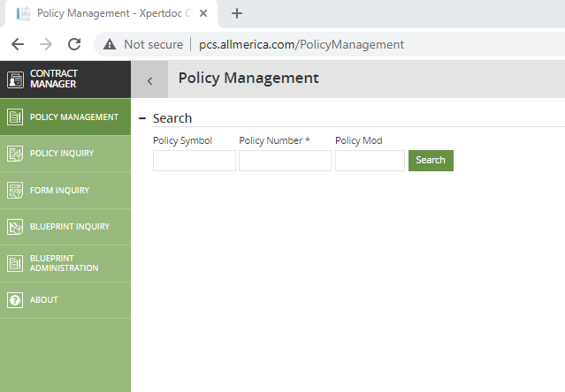

### Step 5: Search for the policy number received in the email in PCS.

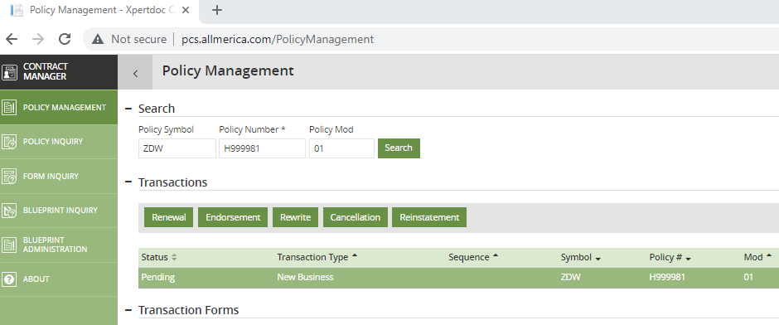

### Step 6: If the policy number is found download the dec pages for the policy, according to the form numbers present in the email.

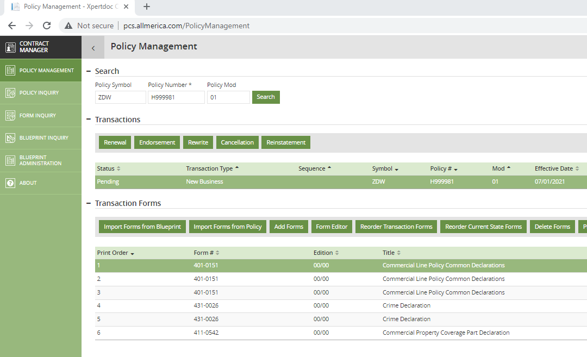

### Step 7: If the policy number is not found, add the policy number, and then download the dec pages for the policy.

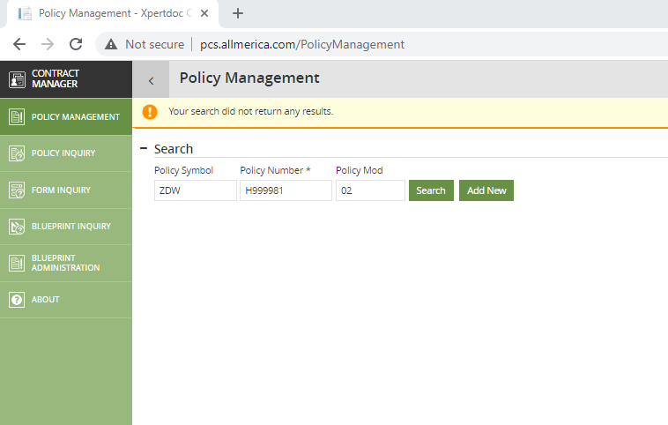

### Step 8: Fill the dec pages with the data from the excel according to the mapping provided.

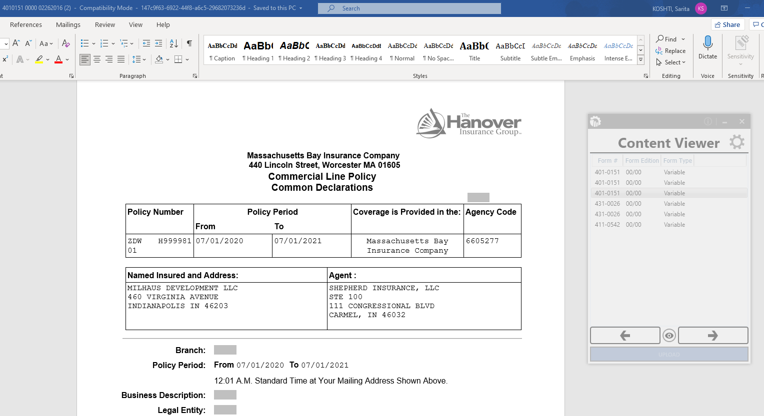

|  |  |  |
| --- | --- | --- |
| Dec Pages | Declaration Fields | QPP Fields |
| General Liability Coverage: 421-0340 | Audit Frequency: | Audit Frequency: |
| General Liability Coverage: 421-0340 | General Aggregate Limit | General Aggregate Limit |
| General Liability Coverage: 421-0340 | Products-Completed Operations Aggregate Limit | Products – Completed Operations Aggregate Limit |
| General Liability Coverage: 421-0340 | Each Occurrence Limit | Each Occurrence Limit |
| General Liability Coverage: 421-0340 | Personal and Advertising Injury Limit | Personal and Advertising Injury Limit |
| General Liability Coverage: 421-0340 | Damage to Premises Rented to You Limit | Damage to Premises Rented to You Limit |
| General Liability Coverage: 421-0340 | Medical Expense Limit, Any One Person | Medical Expense Limit - any one person |
| General Liability Coverage: 421-0340 | Total Advance Commercial General Liability Premium | Total Quoted Commercial General Liability Premium |
| General Liability Coverage: 421-0340 | Form Number | Form Number |
| General Liability Coverage: 421-0340 | Edition Date | Edition Date |
| General Liability Coverage: 421-0340 | Description | Description |
| General Liability Classification: 421-0341 | LOC | LOCATION |
| General Liability Classification: 421-0341 | ST | STATE |
| General Liability Classification: 421-0341 | TERR | TERR |
| General Liability Classification: 421-0341 | CODE | CODE |
| General Liability Classification: 421-0341 | SUBLINE | SUBLINE |
| General Liability Classification: 421-0341 | PREMIUM BASIS | PREMIUM BASIS |
| General Liability Classification: 421-0341 | PER | PER |
| General Liability Classification: 421-0341 | RATE | RATE |
| General Liability Classification: 421-0341 | ADVANCE PREMIUM | PREMIUM |
| General Liability Classification: 421-0341 | Miscellaneous/Optional General Liability Coverages | Miscellaneous/Optional General Liability Coverages |
| Crime Dec Page: 431-0026 | Total Crime Premium | Total Quoted Commercial Crime Premium |
| Crime Dec Page: 431-0026 | Blanket/Schedule | Location |
| Crime Dec Page: 431-0026 | Type of Coverage | Coverage |
| Crime Dec Page: 431-0026 | Limit | Limit |
| Crime Dec Page: 431-0026 | Deductible | Ded |
| Crime Dec Page: 431-0026 | Premium | Premium |
| Crime Dec Page: 431-0026 | Forms Applicable to Crime Coverage Parts: | Forms Applicable To Crime Coverage Part: |
| Crime Dec Page: 431-0026 | Form Number | Form Number |
| Crime Dec Page: 431-0026 | Edition Date | Edition Date |
| Crime Dec Page: 431-0026 | Description | Description |
| Crime Dec Page: 431-0026 | ERISA Plan Name | **Comes from rater email** |
| Crime Dec Page: 431-0026 | ERISA Total Asset Value | **Comes from rater email** |
| Cyber Dec Page-850-0002 | Coverage is provided by: | Insurance Company |
| Cyber Dec Page-850-0002 | NAMED INSURED: | Prepared For: |
| Cyber Dec Page-850-0002 | Inception Date: | Effective Date: |
| Cyber Dec Page-850-0002 | Expiration Date: | Expiration Date: |
| Cyber Dec Page-850-0002 | Maximum Aggregate Limit of Liability | Maximum Aggregate Limit of Liability: |
| Cyber Dec Page-850-0002 | Prior and Pending Proceedings Date: | Prior and Pending Proceedings Date: |
| Cyber Dec Page-850-0002 | Retroactive Date: | Retroactive Date: |
| Cyber Dec Page-850-0002 | Privacy and Security Liability | Privacy and Security Liability |
| Cyber Dec Page-850-0002 | Cyber Media Liability | Cyber Media Liability |
| Cyber Dec Page-850-0002 | PREMIUM FOR COVERAGE PART | Total Quoted Cyber Liability Premium: |
| Cyber Dec Page-850-0002 | Form Number | Form Number |
| Cyber Dec Page-850-0002 | Edition Date | Edition Date |
| Cyber Dec Page-850-0002 | Name | Description |
| Flood Dec Page:411-0775 | Maximum Per “Occurrence” Limit Of Insurance | Maximum Per “Occurrence” Limit Of Insurance |
| Flood Dec Page:411-0775 | Maximum Annual Aggregate Limit Of Insurance | Maximum Annual Aggregate Limit Of Insurance |
| Flood Dec Page:411-0775 | BLANKET FLOOD | BLANKET FLOOD |
| Flood Dec Page:411-0775 | Per “Occurrence” - Limit Of Insurance | Per “Occurrence” - Limit Of Insurance |
| Flood Dec Page:411-0775 | Annual Aggregate - Limit Of Insurance | Annual Aggregate - Limit Of Insurance |
| Flood Dec Page:411-0775 | Premium | Premium |
| Flood Dec Page:411-0775 | Location No | Location No |
| Flood Dec Page:411-0775 | Building No. | Building No. |
| Flood Dec Page:411-0775 | Building Address: | Building Address: |
| Flood Dec Page:411-0775 | Building Deductible | Building Deductible |
| Flood Dec Page:411-0775 | Personal Property Deductible | Personal Property Deductible |
| Flood Dec Page:411-0775 | SCHEDULED FLOOD | SCHEDULED FLOOD |
| Flood Dec Page:411-0775 | Per “Occurrence” - Limit Of Insurance | Per “Occurrence” - Limit Of Insurance |
| Flood Dec Page:411-0775 | Annual Aggregate - Limit Of Insurance | Annual Aggregate - Limit Of Insurance |
| Flood Dec Page:411-0775 | Premium | Premium |
| Flood Dec Page:411-0775 | Location No | Location No |
| Flood Dec Page:411-0775 | Building No. | Building No. |
| Flood Dec Page:411-0775 | Building Address: | Building Address: |
| Flood Dec Page:411-0775 | Building Deductible | Building Deductible |
| Flood Dec Page:411-0775 | Personal Property Deductible | Personal Property Deductible |
| Flood Dec Page:411-0775 | Additional Premium to Meet Minimum Premium | Additional Premium to Meet Minimum Premium |
| Flood Dec Page:411-0775 | Total Flood Premium | Total Flood Premium |
| Earth Movement Dec Page:411-0773 | Maximum Per “Occurrence” Limit Of Insurance | Maximum Per “Occurrence” Limit Of Insurance |
| Earth Movement Dec Page:411-0773 | Maximum Annual Aggregate Limit Of Insurance | Maximum Annual Aggregate Limit Of Insurance |
| Earth Movement Dec Page:411-0773 | BLANKET EARTH MOVEMENT | BLANKET EARTH MOVEMENT |
| Earth Movement Dec Page:411-0773 | Per “Occurrence” - Limit Of Insurance | Per “Occurrence” - Limit Of Insurance |
| Earth Movement Dec Page:411-0773 | Annual Aggregate - Limit Of Insurance | Annual Aggregate - Limit Of Insurance |
| Earth Movement Dec Page:411-0773 | Premium | Premium |
| Earth Movement Dec Page:411-0773 | Location No | Location No |
| Earth Movement Dec Page:411-0773 | Building No. | Building No. |
| Earth Movement Dec Page:411-0773 | Building Address: | Building Address: |
| Earth Movement Dec Page:411-0773 | Building Deductible | Building Deductible |
| Earth Movement Dec Page:411-0773 | Personal Property Deductible | Personal Property Deductible |
| Earth Movement Dec Page:411-0773 | SCHEDULED EARTH MOVEMENT | SCHEDULED EARTH MOVEMENT |
| Earth Movement Dec Page:411-0773 | Per “Occurrence” - Limit Of Insurance | Per “Occurrence” - Limit Of Insurance |
| Earth Movement Dec Page:411-0773 | Annual Aggregate - Limit Of Insurance | Annual Aggregate - Limit Of Insurance |
| Earth Movement Dec Page:411-0773 | Premium | Premium |
| Earth Movement Dec Page:411-0773 | Location No | Location No |
| Earth Movement Dec Page:411-0773 | Building No. | Building No. |
| Earth Movement Dec Page:411-0773 | Building Address: | Building Address: |
| Earth Movement Dec Page:411-0773 | Building Deductible | Building Deductible |
| Earth Movement Dec Page:411-0773 | Personal Property Deductible | Personal Property Deductible |
| Earth Movement Dec Page:411-0773 | Additional Premium to Meet Minimum Premium | Additional Premium to Meet Minimum Premium |
| Earth Movement Dec Page:411-0773 | Total Earth Movement Premium | Total Earth Movement Premium |
| Earthquake Sprinkler Leakage Dec Page:411-0777 | Maximum Per “Occurrence” Limit Of Insurance | Maximum Per “Occurrence” Limit Of Insurance |
| Earthquake Sprinkler Leakage Dec Page:411-0777 | Maximum Annual Aggregate Limit Of Insurance | Maximum Annual Aggregate Limit Of Insurance |
| Earthquake Sprinkler Leakage Dec Page:411-0777 | BLANKET EARTHQUAKE SPRINKLER LEAKAGE | BLANKET EARTHQUAKE SPRINKLER LEAKAGE |
| Earthquake Sprinkler Leakage Dec Page:411-0777 | Per “Occurrence” - Limit Of Insurance | Per “Occurrence” - Limit Of Insurance |
| Earthquake Sprinkler Leakage Dec Page:411-0777 | Annual Aggregate - Limit Of Insurance | Annual Aggregate - Limit Of Insurance |
| Earthquake Sprinkler Leakage Dec Page:411-0777 | Premium | Premium |
| Earthquake Sprinkler Leakage Dec Page:411-0777 | Location No | Location No |
| Earthquake Sprinkler Leakage Dec Page:411-0777 | Building No. | Building No. |
| Earthquake Sprinkler Leakage Dec Page:411-0777 | Building Address: | Building Address: |
| Earthquake Sprinkler Leakage Dec Page:411-0777 | Building Deductible | Building Deductible |
| Earthquake Sprinkler Leakage Dec Page:411-0777 | Personal Property Deductible | Personal Property Deductible |
| Earthquake Sprinkler Leakage Dec Page:411-0777 | SCHEDULED EARTHQUAKE SPRINKLER LEAKAGE | SCHEDULED EARTHQUAKE SPRINKLER LEAKAGE |
| Earthquake Sprinkler Leakage Dec Page:411-0777 | Per “Occurrence” - Limit Of Insurance | Per “Occurrence” - Limit Of Insurance |
| Earthquake Sprinkler Leakage Dec Page:411-0777 | Annual Aggregate - Limit Of Insurance | Annual Aggregate - Limit Of Insurance |
| Earthquake Sprinkler Leakage Dec Page:411-0777 | Premium | Premium |
| Earthquake Sprinkler Leakage Dec Page:411-0777 | Location No | Location No |
| Earthquake Sprinkler Leakage Dec Page:411-0777 | Building No. | Building No. |
| Earthquake Sprinkler Leakage Dec Page:411-0777 | Building Address: | Building Address: |
| Earthquake Sprinkler Leakage Dec Page:411-0777 | Building Deductible | Building Deductible |
| Earthquake Sprinkler Leakage Dec Page:411-0777 | Personal Property Deductible | Personal Property Deductible |
| Earthquake Sprinkler Leakage Dec Page:411-0777 | Additional Premium to Meet Minimum Premium | Additional Premium to Meet Minimum Premium |
| Earthquake Sprinkler Leakage Dec Page:411-0777 | Total Earthquake Sprinkler Leakage Premium | Total Earthquake Sprinkler Leakage Premium |
| Inland Marine Dec Page:411-0205 | Total Inland Marine Premium | Total Quoted Commercial Inland Marine Premium |
| Inland Marine Dec Page:411-0205 | LOC | Location |
| Inland Marine Dec Page:411-0205 | BLDG | Building |
| Inland Marine Dec Page:411-0205 | Type of Coverage | Coverage |
| Inland Marine Dec Page:411-0205 | Premium | Premium |
| Inland Marine Dec Page:411-0205 | Limit | Limit |
| Inland Marine Dec Page:411-0205 | Deductible | Ded |
| Inland Marine Dec Page:411-0205 | Form Number | Form Number |
| Inland Marine Dec Page:411-0205 | Edition Date | Edition Date |
| Inland Marine Dec Page:411-0205 | Description | Description |
| Inland Marine Dec Page:411-0205 | Terrorism Premium | Terrorism Premium |
| Inland Marine Dec Page:411-0205 | Contractors’ Equipment Coverage Premium | Contractors’ Equipment Coverage Premium |
| Property Dec page: 411-0542 | Total Property Premium | Total Quoted Commercial Property Premium |
| Property Dec page: 411-0542 | Blanket Building and Contents For Premises | Subject of Insurance: |
| Property Dec page: 411-0542 | Location No , Building No | Location No , Building No |
| Property Dec page: 411-0542 | Blanket Business Income For Premises | Subject of Insurance: |
| Property Dec page: 411-0542 | Location No , Building No | Location No , Building No |
| Property Dec page: 411-0542 | Blanket Building For Premises | Subject of Insurance: |
| Property Dec page: 411-0542 | Location No , Building No | Location No , Building No |
| Property Dec page: 411-0542 | Blanket Contents For Premises | Subject of Insurance: |
| Property Dec page: 411-0542 | Location No , Building No | Location No , Building No |
| Property Dec page: 411-0542 | Coverage,Cause of Loss,Premiums | Coverage, Blanket Coverage Limit, Coinsurance, Premium |
| Property Dec page: 411-0542 | Limit of Insurance: | Limit |
| Property Dec page: 411-0542 | Coinsurance: | Coinsurance: |
| Property Dec page: 411-0542 | Agreed Value | Agreed Value Expiration Date: |
| Property Dec page: 411-0542 | LOC, BLDG, Cause of Loss, Premiums | Location, Building, Coverage, Covered Cause of Loss |
| Property Dec page: 411-0542 | Extended Period of Indemnity: | Extended Period of Indemnity: |
| Property Dec page: 411-0542 | Business Income Time Deductible | Hour Deductible: |
| Property Dec page: 411-0542 | Occupancy: | Occupancy Description: |
| Property Dec page: 411-0542 | Limit Of Insurance: | Limit: |
| Property Dec page: 411-0542 | Coinsurance | Coinsurance: |
| Property Dec page: 411-0542 | Windstorm/HailDeductible | Wind/Hail Flat Ded |
| Property Dec page: 411-0542 | Theft Deductible | Deductible |
| Property Dec page: 411-0542 | Miscellaneous/Optional Property Coverages, PREMIUM | Coverage, Limit, Premium |
| Property Dec page: 411-0542 | Terrorism Premium | Total Terrorism Premium |
| Property Dec page: 411-0542 | Emergency Event Management Coverage | Emergency Event Management Coverage |
| Property Dec page: 411-0542 | Data Breach | Data Breach |
| Property Dec page: 411-0542 | Boiler / Machinery / Equipment Breakdown | Boiler / Machinery/ Equipment Breakdown |
| Property Dec page: 411-0542 | Gold Property Broadening Endorsement | Gold Property Broadening Endorsement |
| Property Dec page: 411-0542 | Real Estate Property Broadening Endorsement | Real Estate Property Broadening Endorsement |
| Property Dec page: 411-0542 | Forms Applicable to Property Coverage Parts: | Forms Applicable to Property Coverage Parts: |
| Property Dec page: 411-0542 | Form Number, Edition Date, Description | Form Number, Edition Date, Description |
| Main Dec Page: 401-0151 | From | Effective Date: |
| Main Dec Page: 401-0151 | To | Expiration Date: |
| Main Dec Page: 401-0151 | Named Insured and Address : | Prepared For: |
| Main Dec Page: 401-0151 | Agent : | Presented By: |
| Main Dec Page: 401-0151 | Commercial Property Coverage | Total Quoted Commercial Property Premium: |
| Main Dec Page: 401-0151 | Commercial General Liability Coverage | Total Quoted Commercial General Liability Premium: |
| Main Dec Page: 401-0151 | Commercial Inland Marine Coverage | Total Quoted Commercial Inland Marine Premium: |
| Main Dec Page: 401-0151 | Commercial Auto Coverage | Non Owned and Hired Auto or Hired Car Physical Damage |
| Main Dec Page: 401-0151 | ** Total | Total Quoted Commercial Policy Premium: |
| Main Dec Page: 401-0151 | Locations of All Premises You Own, Rent or Occupy | Locations Of All The Premises You Own, Rent Or Occupy |
| Main Dec Page: 401-0151 | Forms Applicable To All Coverage Parts: | Forms Applicable To All Coverage Parts: |
| Main Dec Page: 401-0151 | Total Inland Marine Premium | Total Quoted Commercial Inland Marine Premium |
| Main Dec Page: 401-0151 | Contractors’ Equipment Coverage - Leased Or Rented From Others | Contractors’ Equipment Coverage - Leased Or Rented From Others Premium |
| Main Dec Page: 401-0151 | Terrorism Premium | Terrorism Premium |

### Step 9: Upon completion bot will send email to rater with the dec pages.

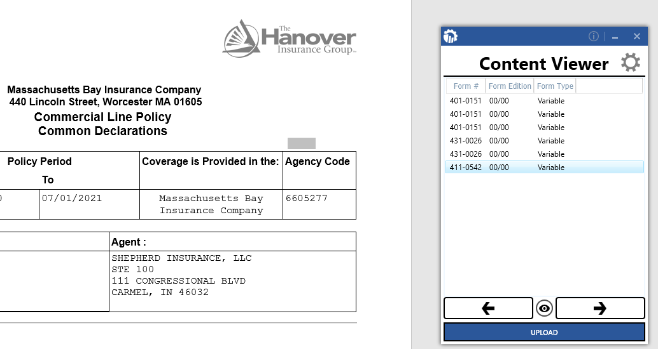

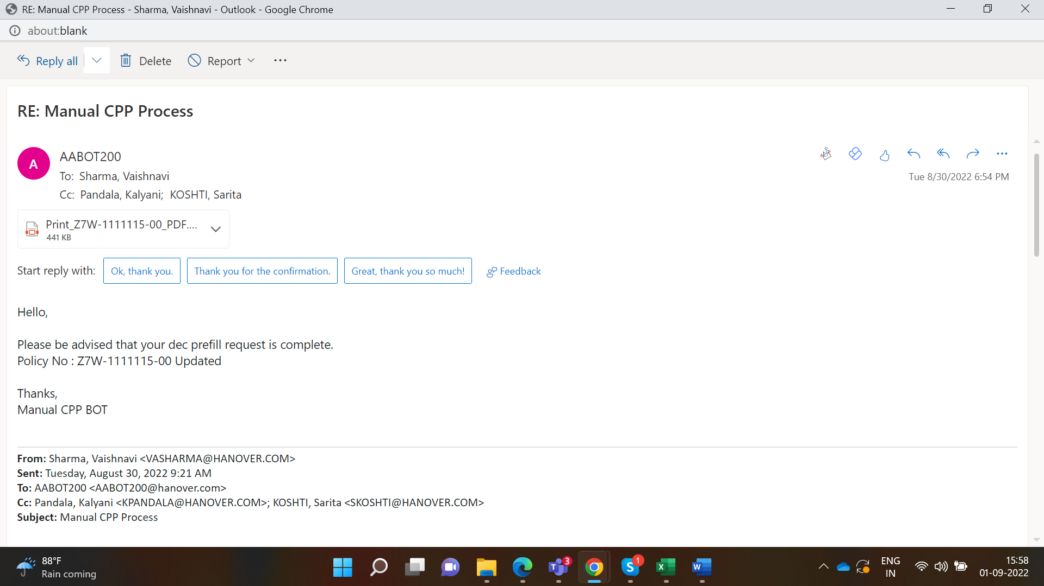

## Target Systems

|  |  |  |  |  |  |  |
| --- | --- | --- | --- | --- | --- | --- |
| **#** | **Application Name & Version** | **System**  **Language** | **Login Module** | **Interface** | **Environment/**  **Access method** | **Comments**  **(Include URLs)** |
| 1 | Outlook 2011 | EN | N/A | Client | Local desktop | Single Sign-On |
| 2 | PCS (POLICY CREATOR SYSTEM) | EN | User Input | Web | Web | User credential login |

## Impacted Business Area

Core Rating - New Business

## Pre-requisites

Pre-requisites required before the development of the solution is:

* An email from rater with policy number and details that are not present in QPP
* The QPP for the Policy
* Access to PCS.
* Test Data to support development.
* Smoke test applications.

## Requirement Details

|  |  |  |  |
| --- | --- | --- | --- |
| **BR ID** | **Requirement** | **Brief Description** | **Priority** |
| BR01 | Read email sent by rater | The rater will be sending an email to the bot account, which will trigger the bot to start the Manual CPP Process. The bot should read the policy details from the email and download the QPP. If the policy details or QPP is not present in the email, the bot will send an error mail back to the user. | High |
| BR02 | Extract required data from QPP (Quote Proposal Package) and Policy Details | The bot will then extract the required information from the QPP and stored it in an excel. | High |
| BR03 | Log into the PCS (POLICY CREATOR SYSTEM) | The bot will log into the PCS system. If the login fails, the bot should send an email for the same. | High |
| BR04 | Search for the policy | The bot will search for the policy number received through email in PCS. | High |
| BR05 | Add the policy to PCS if policy is not found | If the bot fails to find the policy number in PCS, then the bot will click on “Add New” button and add the policy details and add the policy to PCS. | High |
| BR06 | Add required forms | The form numbers to be added for the respective policy will be present in the email. The bot should add the required forms for the policy accordingly. | High |
| BR07 | Download the forms | The bot will click on “Form Editor” to download the forms for editing | High |
| BR08 | Fill the details for the policy | The bot will fill the required details for each policy from the excel that was prepared using the QPP. Once all the forms are filled the bot will click on “Save” to upload the form to PCS | High |
| BR09 | Send email with dec pages | Once the forms are filled the bot will send an email to the rater with the process status and filled dec pages. | High |

# Exceptions Handling

## Business Exceptions Handling

The Business Process Owner and Business Analysts are expected to document below all the business exceptions identified in the automation process. These can be classified as:

| **Known** | **Unknown** |
| --- | --- |
| Valid Email  PCS is not accessible  PCS Business exceptions  QPP or Dec pages are not accessible  PCS login failed  Email functionality not working | The new situation was never encountered earlier. It can be caused by external factors. It cannot be predicted with precision. However, if it occurs, it must be communicated to an authorized person for evaluation. |

**Known Exceptions**

The table below reflects all the business process exceptions captured during the process evaluation and documentation. These are known exceptions, met in practice before. For each of these exceptions, define a corresponding expected action that the automation solution should complete if it encounters the exception.

| **#** | **Exception name** | **Step** | **Parameters** | **Action to be taken** |
| --- | --- | --- | --- | --- |
| 1 | Valid Email Input | Read Email | Policy details | Email Response |
| 2 | PCS is not accessible | Launch PCS | URL | Email Response |

**Unknown Exceptions**

For all the other unanticipated or unknown business (process) exceptions, the automation solution should:

Send an email notification to everyone on the requesting email; with copy to Cindy Hinton and Robin Babst with the original email and error message screenshot attached.

## Application Error and Exceptions Handling

A comprehensive list of all errors, warnings, or notifications should be consolidated here with the description and action to be taken by the automation solution. Errors identified in the automation process can be classified as:

| **Area** | **Known** | **Unknown** |
| --- | --- | --- |
| **Technology /**  **Applications** | Login failed with PCS application  Email is not accessible to read | The PCS application is down or not responding. PCS application is not consistent in steps |

# Assumptions, Risks, Dependencies, and Constraints

## Assumptions

| **A - #** | **Assumption** | **Impacted Business Req #** |
| --- | --- | --- |
| A 1.0 | The Word template will be consistent | ALL |
| A 2.0 | PCS application is stable and no change in process flow | ALL |

## Risks

| **R - #** | **Risk** | **Impacted Business Req. #** | **Probability** | **Risk Treatment/**  **Response** |
| --- | --- | --- | --- | --- |
| R 1.0 | If the QPP or Dec format is changed | *All* | Low | Will need to revisit impact on changes |
|  |  |  |  |  |
|  |  |  |  |  |
|  |  |  |  |  |

## Dependencies

| **D - #** | **Dependency** | **Impacted Business Req. #** |
| --- | --- | --- |
| D 1.0 | The process starting point will be the user email in predefined format | ALL |
| D 2.0 | PCS application access to Bot | ALL |

## Constraints

| **#** | **Constraints** | **Impacted Business Req. #** |
| --- | --- | --- |
| C 1.0 | None |  |
|  |  |  |

# Additional Information

|  |  |
| --- | --- |
| **Reference Documents** | BRD |
| **Video Location** | NA |

# Acronyms and Glossary

|  |  |
| --- | --- |
| **Acronym / Term** | **Expansion / Definition** |
| BRD | Business Requirement Document |
| FRS | Functional Requirement Specification |
| PDD | Process Design Document |
| CPP | Commercial Package Policy |
| PCS | Policy Creator System |
| QPP | Quote Proposal PDF |

# Change History

|  |  |  |  |  |  |
| --- | --- | --- | --- | --- | --- |
| **Version #** | **Overview of Changes** | **Sections Changed** | **Changed By** | **Date** | **Approved By** |
| 0.2 |  | 1. Requirement Details 2. Step 1 3. Current State | Vaishnavi Sharma | 04-08-2022 |  |
| 0.3 |  | In scope | Vaishnavi Sharma |  |  |